Assignment 7: optional catchup assignment 2 - VERTEX AI - for midterm and quiz - this will catch up midterm.

1. Vertex AI pipeline Intro

Reference: <https://codelabs.developers.google.com/vertex-pipelines-intro#0>

Objectives:

* Use the Kubeflow Pipelines SDK to build scalable ML pipelines
* Create and run a 3-step intro pipeline that takes text input
* Create and run a pipeline that trains, evaluates, and deploys an AutoML classification model
* Use pre-built components for interacting with Vertex AI services, provided through the google_cloud_pipeline_components library
* Schedule a pipeline job with Cloud Scheduler

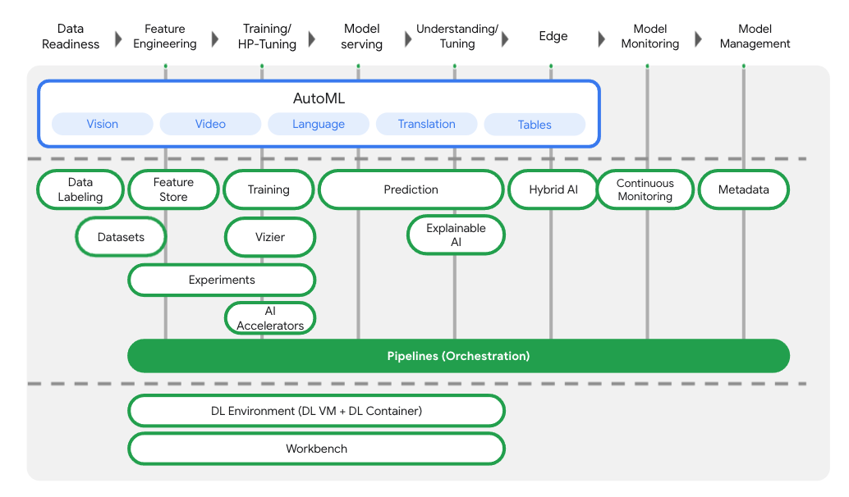

Cloud environment setup:

Enable API services and create google bucket:

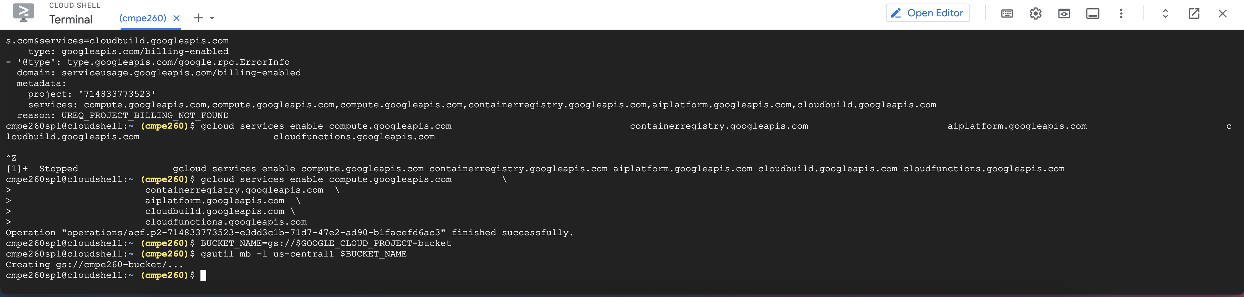

Create a Vertex AI workbench instance:

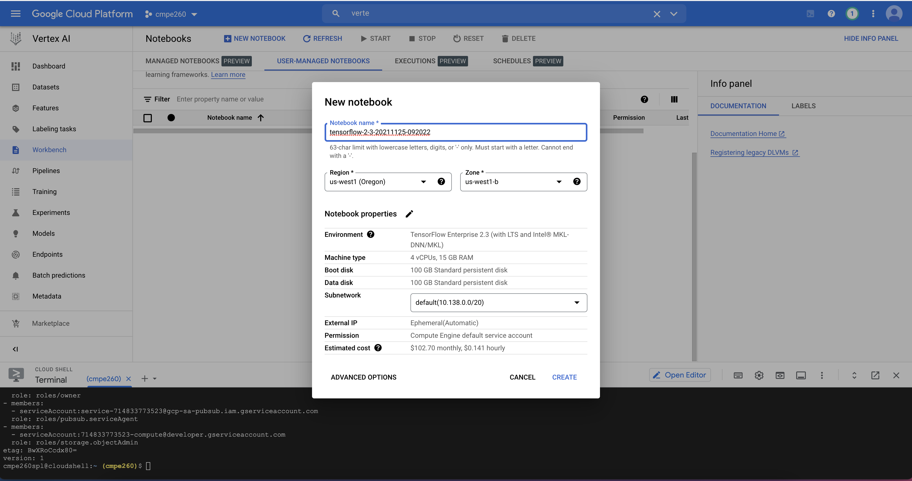

Vertex pipeline setup

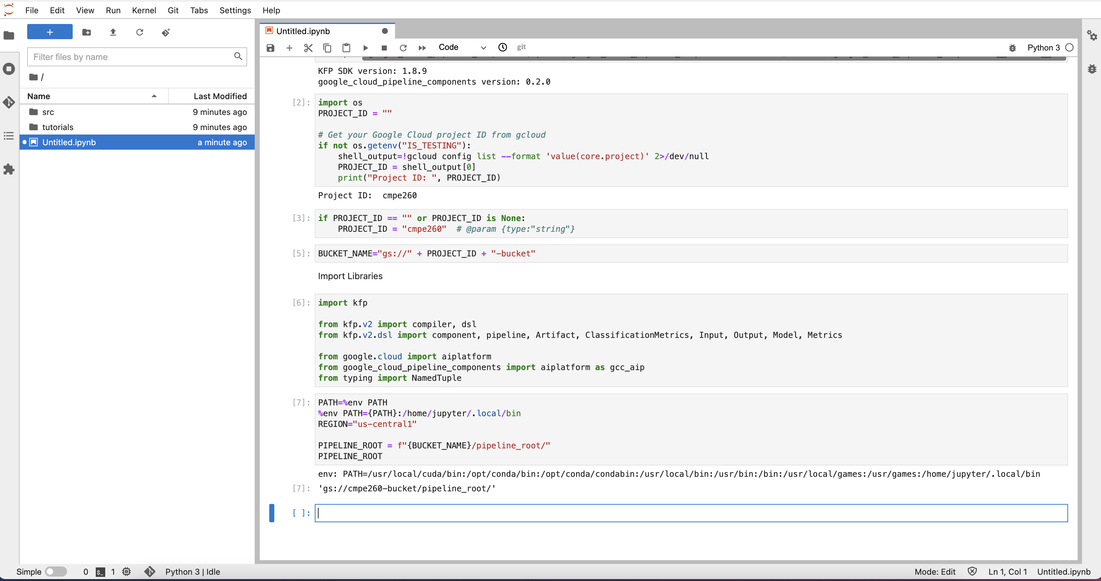

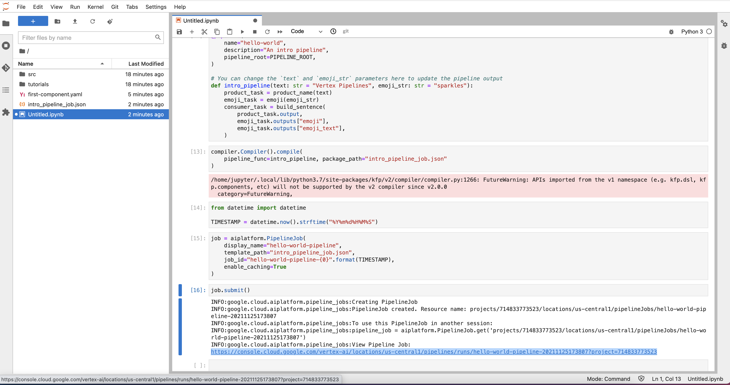

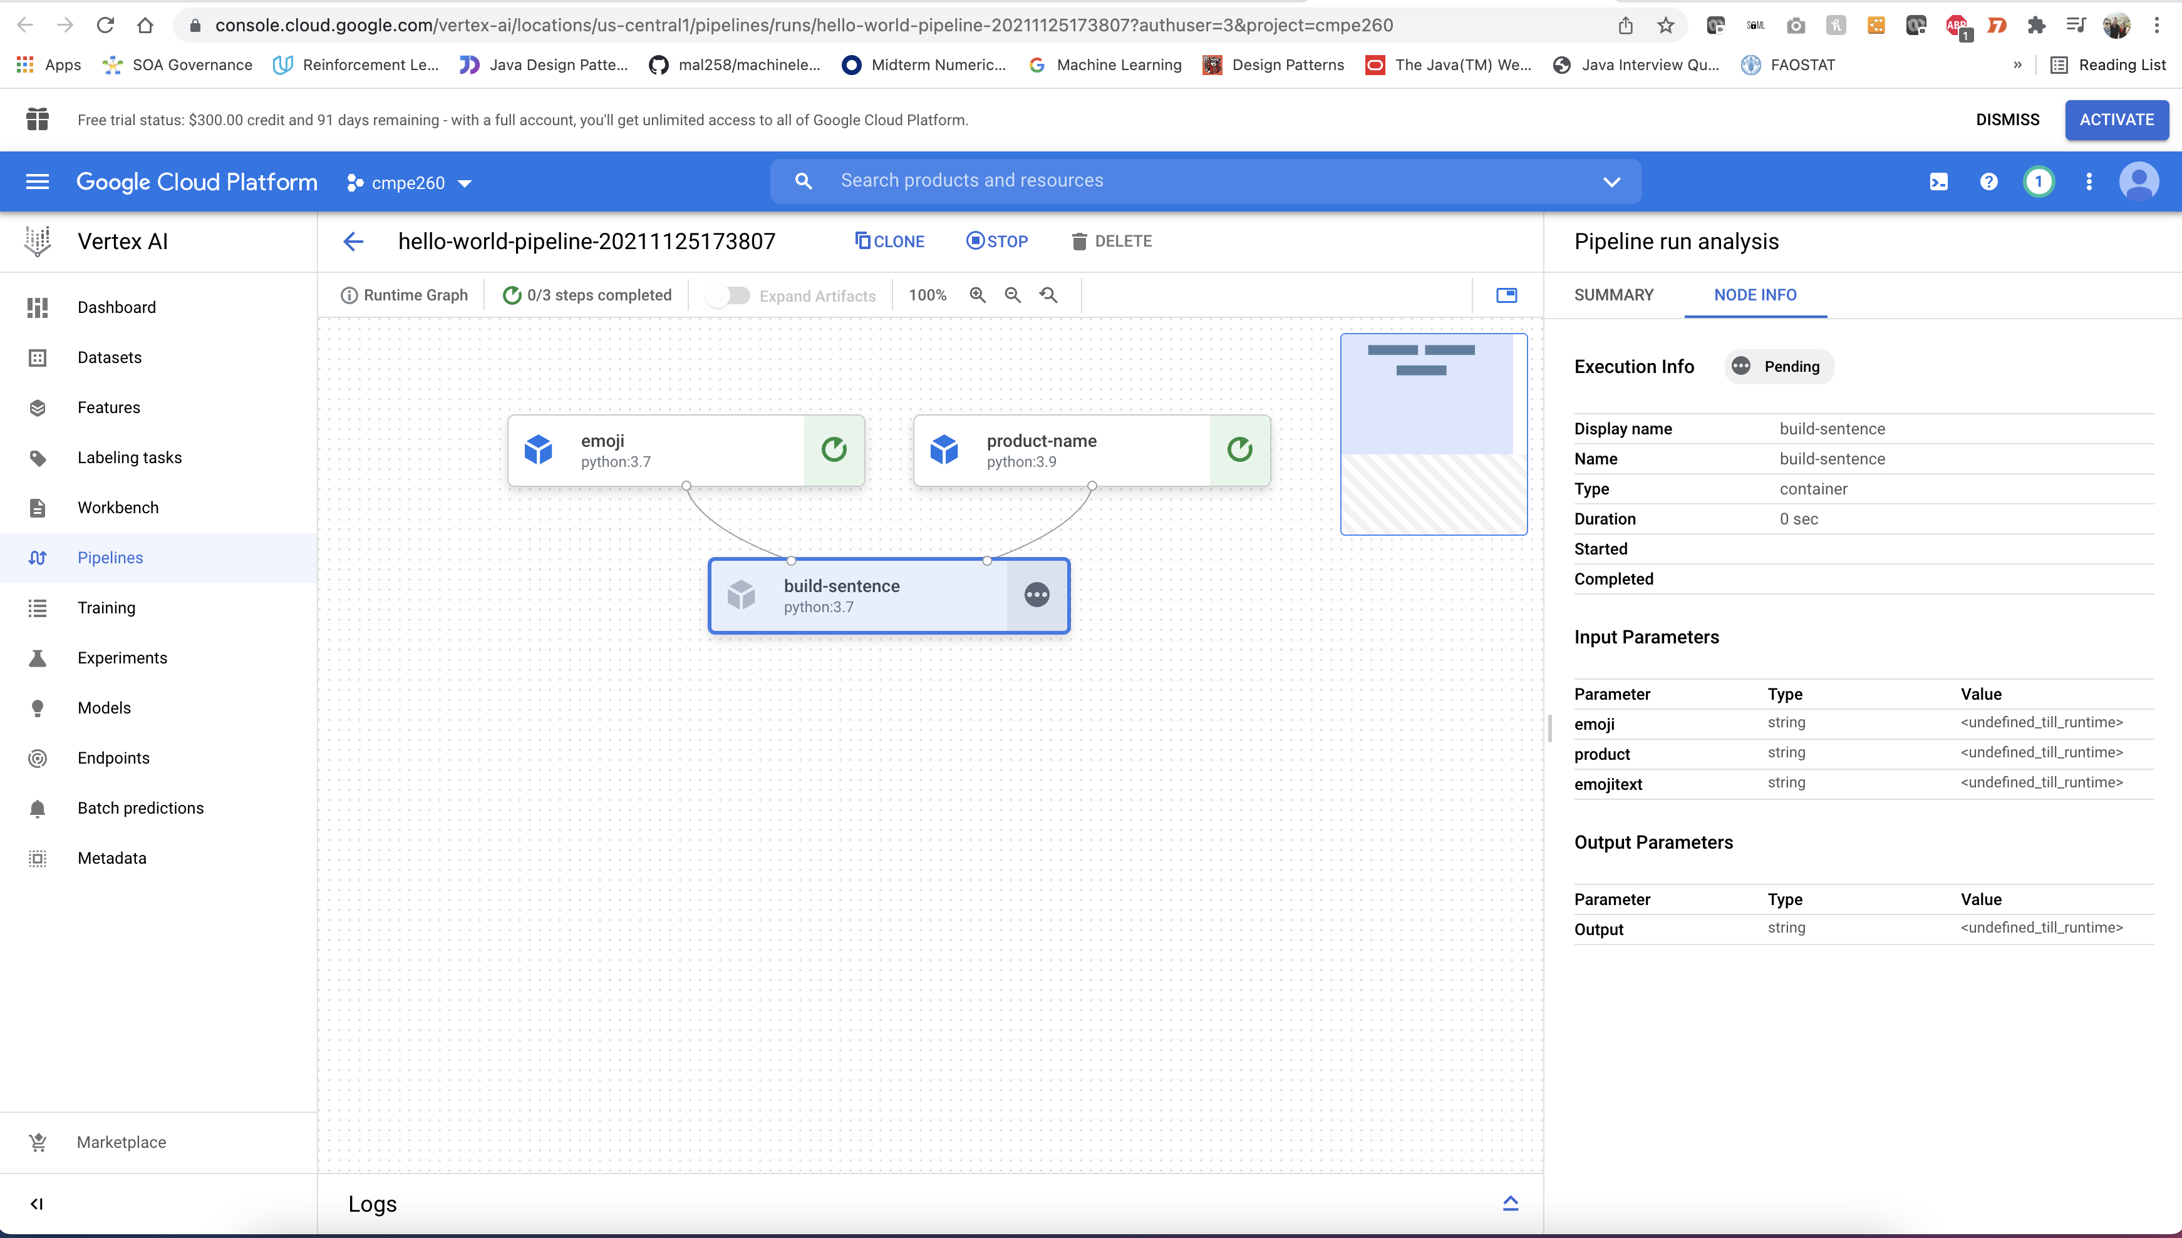

Creating an end to end ML pipeline

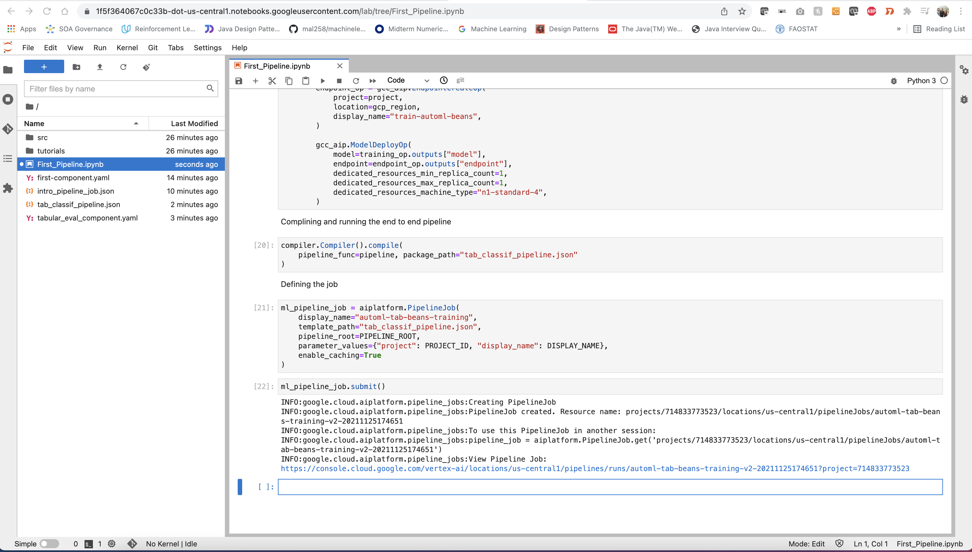

Compiling and running the pipeline

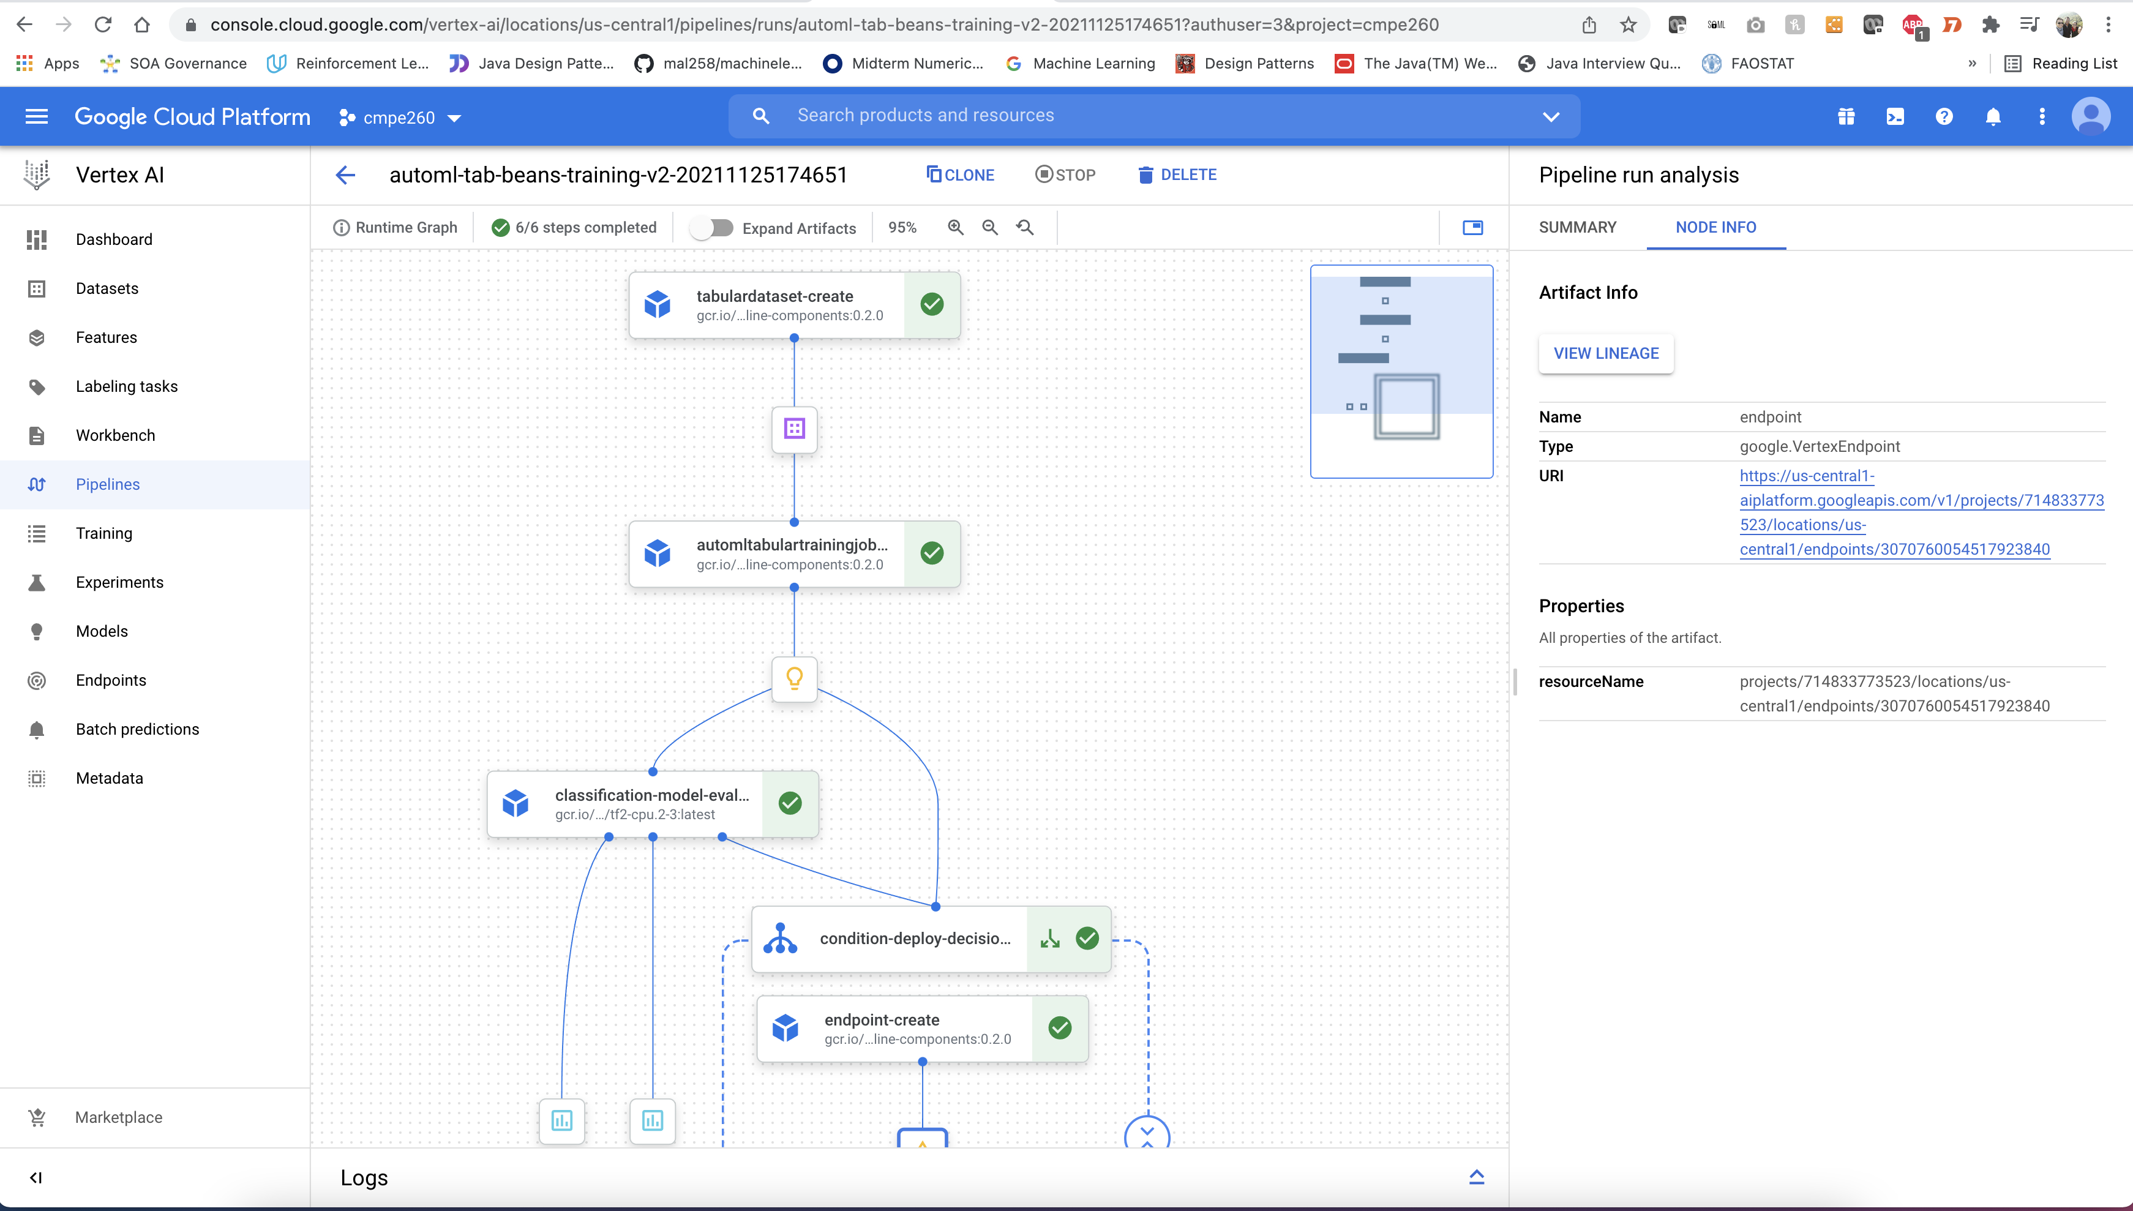

Data Set and End Point View

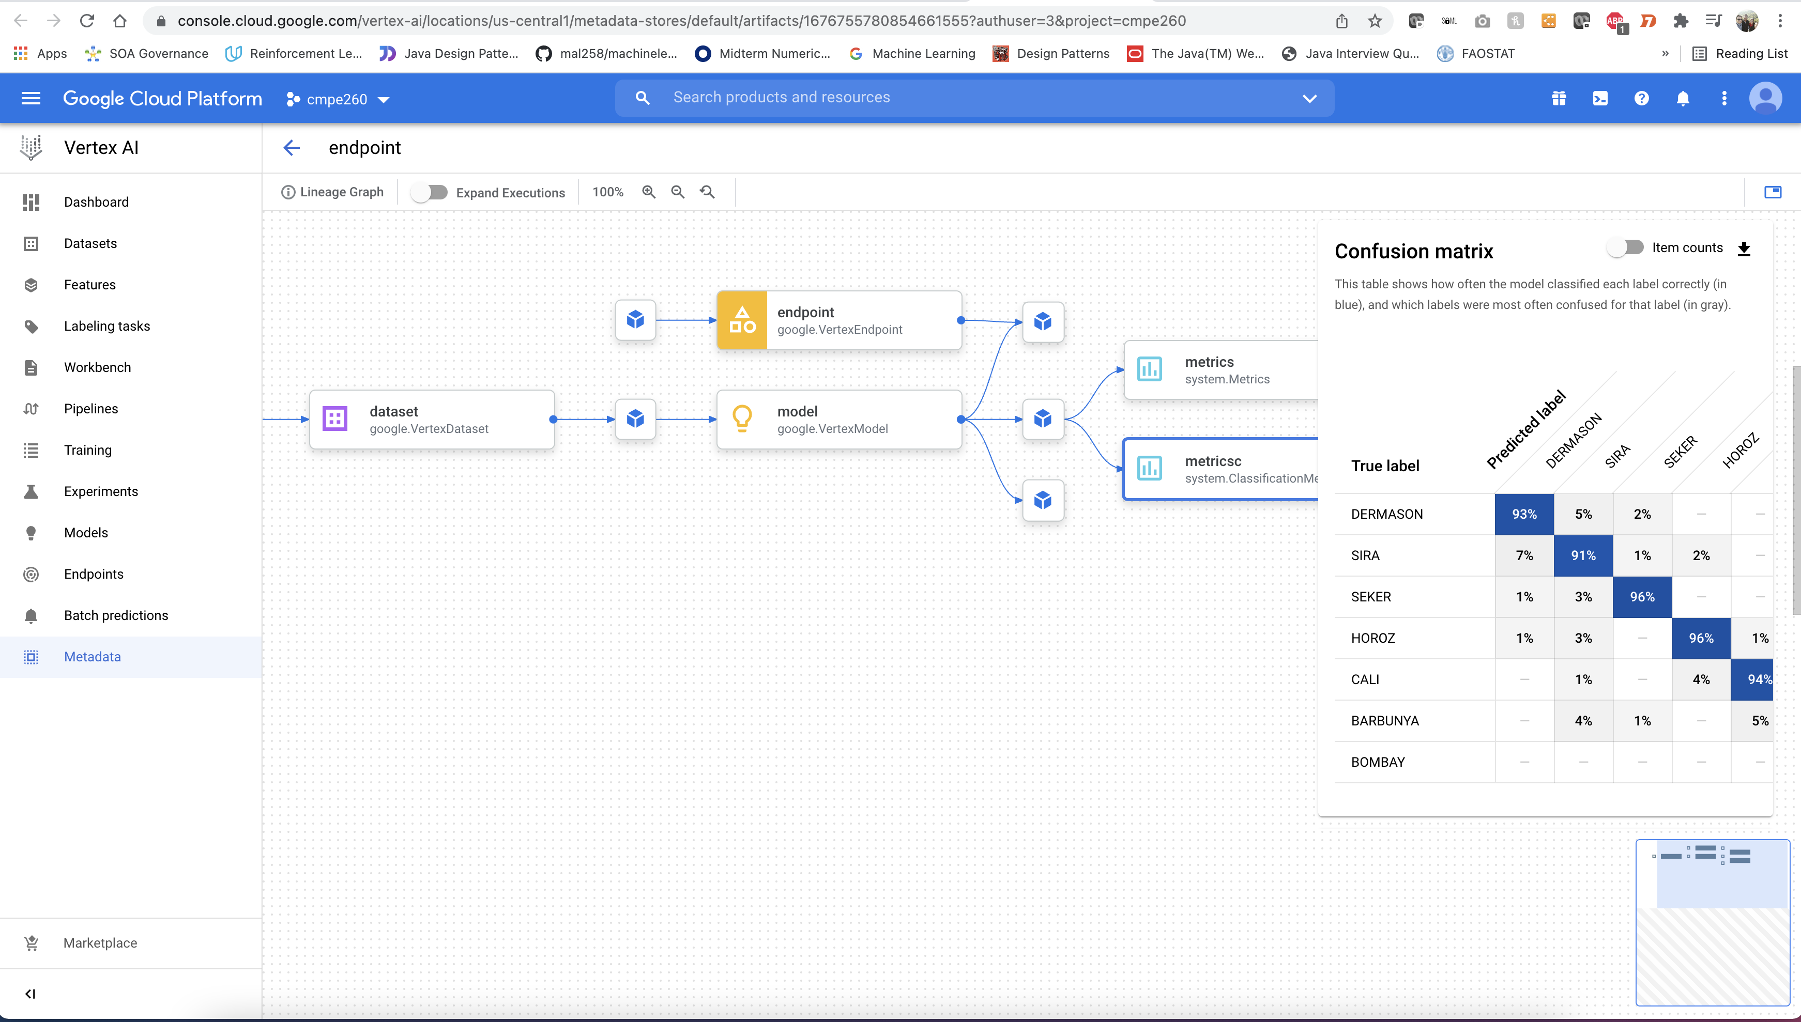

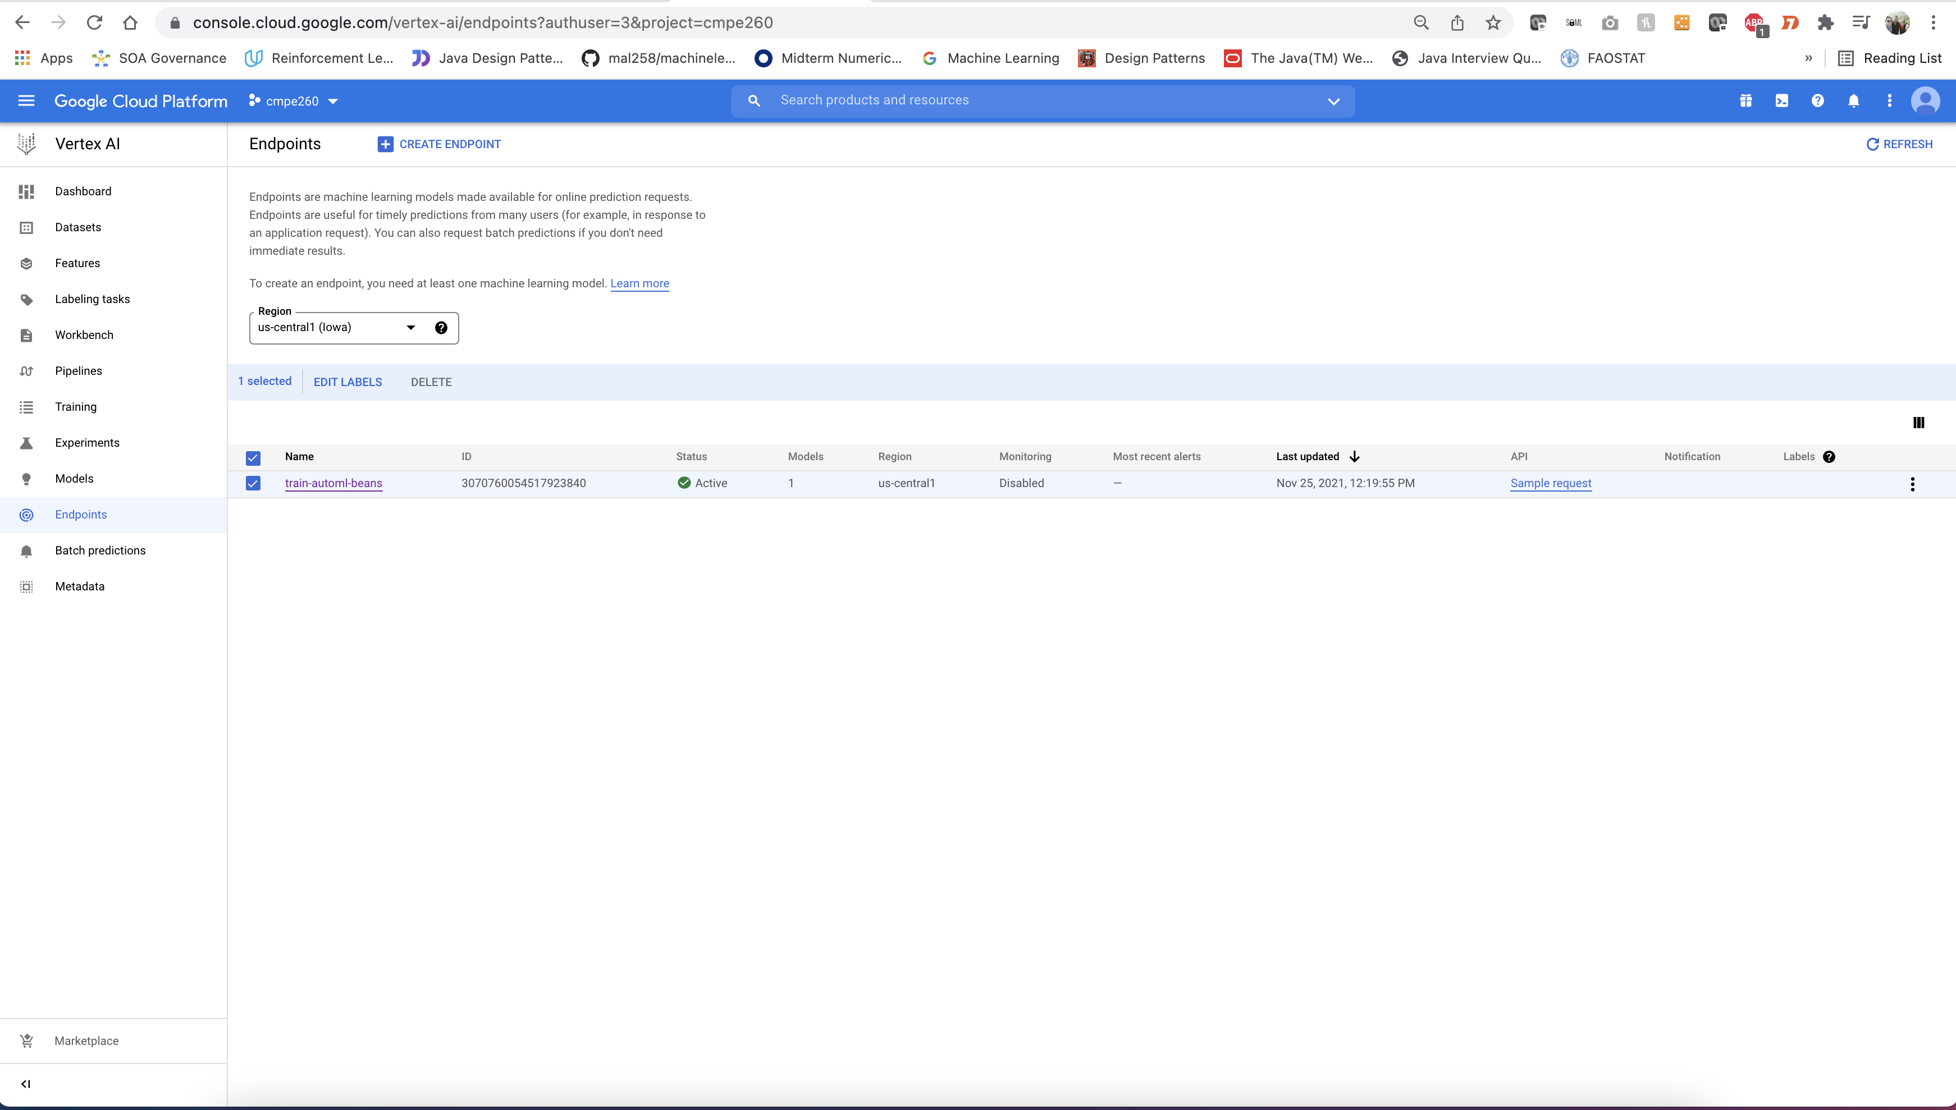

Model Output

